Q3. This question is about the end of the Weimar Republic.
Study the source below and then answer the question which follows.
Source B
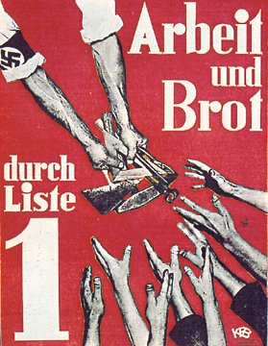

[A Nazi election poster, 1932. The text reads ‘Work and Bread’]

What was the purpose of source B? [8]
(Use details from Source B and your own knowledge and understanding of the historical context to answer the question.)
____________________________________________________________________________________________________________________________________________________________________________________________________________________________________________________________________________________________________________________________________________________________________________________________________________________________________________________________________________________________________________________________________________________________________________________________________________________________________________________________________________________________________________________________________________________________________________________________________________________________________________________________________________________________________________________________________________________________________________________________________________________________________________________________________________________________________________________________________________________________________________________________________________________________________________________________________________________________________________________________________________________________________________________________________________________________________________________________________________________________________________________________________________________________________________________________________________________________________________________________________________________________________________________________________________________________________________________________________________________________________________________________________________________________________________________________________________________________________________________________________________________________________________________________________________________________________________________________________________________________________________________________________________________________________________________________________________________________________________________________________________________________________________________________________________________________________________________________________________________________________________________________________

